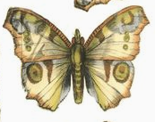I would like the outline to be like this first picture but where I would like a little bit more of a gap where the top wings meet the bottom wings like the one below. The edges of the pictures above and the body are what I like from above.

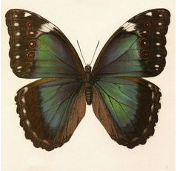I like the gap between the top and bottom wings in this picture.

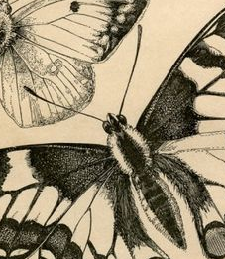 This head words for me. I do not want the eyes to be noticeable, blended in is good. I like these antennas as well.

I’m guessing it will need some sort of pattern to mask/blend the current one. I found these patterns and enjoyed them. These are about pattern and not about color.

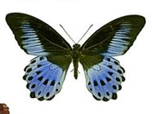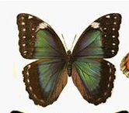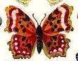

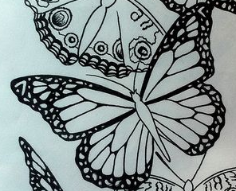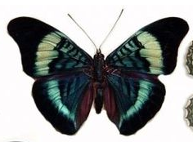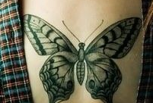

As for colors…I love grey, mauves, soft brown, faded mint, blues . I like the hazy colors more than the bold ones. I understand I’m limited on colors for the areas that overlap the old tattoo but I wanted to give you some ideas. I like the color palette shown below, as a starting place.

